ATTACHMENT 15 – RECOMMENDED CONDITIONS OF CONSENT

- GENERAL CONDITIONS

Approved Plans / Documents

- Development the subject of this determination notice must be carried out strictly in accordance with the following approved plans / reports marked as follows, except where modified by the undermentioned conditions.

Plan Name | Plan Number | Date | Prepared By
Basement Envelope Plan | MP-002 | 2/05/2020 | FJMT
Envelope Plan | MP-001 | 2/05/2020 | FJMT
Envelope Section A | MP-005 | 2/05/2020 | FJMT
Envelope Section B & C | MP-006 | 2/05/2020 | FJMT
Envelope Perspective North | MP-003 | 2/05/2020 | FJMT
Envelope Perspective South | MP-004 | 2/05/2020 | FJMT
Envelope Perspective East | MP-007 | 2/05/2020 | FJMT

Environmental Planning and Assessment Act 1979

- In accordance with section 4.22(4) of the EP&A Act all development under the Concept Proposal must be subject of future application(s). This consent does not permit the carrying out of any works.

Land uses

- This consent does not approve any residential land uses on the subject site.

Public Domain and Landscaping – Design Excellence

- Prior to the determination of any Detailed DA subject to this Concept Approval, a detailed Public Domain and Landscape Plan must be prepared by a suitably qualified AILA Registered Landscape Architect or Urban Designer, in accordance with the requirements of this condition.

The Public Domain and Landscape Plan is to undertake a design review process to ensure Design Excellence of the public domain is achievable in accordance with Clause 7.5 of Liverpool Local Environmental Plan 2008. A minimum of two (2) design review workshops, facilitated by the nominated chair of the Design Excellence Panel, are to be held with the applicant and a Public Domain Design Panel, consisting of:

- The Design Excellence Panel (including the GANSW representative and a minimum of two additional members including a suitably qualified landscape architect and urban designer);
- Representatives of Liverpool City Council’s City Design and Public Domain team; and
- Other relevant technical officers of Liverpool City Council including, but not limited to, Heritage, Traffic, Public Art, Community Planning, Indigenous Culture and Heritage, and Community Development.

Recommendations made by the Public Domain Design Panel through this process are to be appropriately addressed prior to endorsement of the Public Domain Plan.

Evidence is to be provided to Liverpool City Council’s Manager Development Assessment and Manager City Design and Public Domain that satisfactorily demonstrates the Public Domain Plan has been endorsed by the Public Domain Design Panel prior to the determination of any future Detailed DA subject to this Concept Approval.

- The Public Domain and Landscape Plan is to:

- Identify any landscape constraints, including (but not limited to) setbacks, existing street trees, landscape features, screening / buffer requirements
- Include public domain design guidelines that are to be implemented across the subject site
- Identify the location of public domain areas within the site, providing detail on their role, character and extent
- Set aspirations and principles for each public domain area in order to achieve Design Excellence in accordance with Clause 7.5 of Liverpool Local Environmental Plan 2008
- Identify the location of trees, planters, water sensitive urban design treatments, deep soil and direct sunlight to public domain areas
- Detail design principles for roof terraces, including (but not limited to) how planting, deep soil, access and shade would be implemented
- Identify any intended design elements such as green roofs and walls, water sensitive landscape design treatments and sustainability targets
- Demonstrate consistency with the relevant landscape provisions of the Liverpool Development Control Plan 2008 and Liverpool City Centre Public Domain Master Plan
- Demonstrate how the public domain areas will relate to proposed future built form within site, including consideration of pedestrian movements to and between buildings within the site
- All future detailed Development Applications subject to this Concept approval will also need to demonstrate consistency with the endorsed Public Domain and Landscape Plan.
Traffic and Access

- Prior to the determination of a Detailed DA, a Local Area Traffic Management Plan is to be submitted to Council’s Traffic and Transport Section and to the Liverpool Pedestrian Active Transport and Traffic Committee for endorsement. The Local Area Traffic Management Plan is to identify traffic infrastructure improvements including changes to the adjoining traffic signals, signs, line markings and timed parking restrictions.

Transport for NSW Conditions

- Future Detailed DAs subject to this Concept Approval shall comply with all conditions provided by Transport for NSW dated 12 August 2020. A copy of the conditions is attached to this decision notice (Attachment 1). Note: the conditions do not constitute a Section 138 concurrence under the Roads Act 1993.

- CONDITIONS TO BE SATISFIED PRIOR TO THE SUBMISSION OF FUTURE DEVELOPMENT APPLICATIONS

Pre-Development Application Meeting

- Prior to the submission of an application for the built form a Pre-Development application meeting is to be undertaken with Liverpool City Council. Advice of the subject Pre-Development application meeting is to be accompanied with the submission of the development application.

- CONDITIONS TO BE SATISFIED IN FUTURE DEVELOPMENT APPLICATIONS

Building Envelopes

- Built form proposed in any future Detailed DA subject to this Concept Approval is not permitted to extend beyond the building envelopes approved under DA-585/2019.

Public Domain and Landscaping – Design Excellence

- All future detailed Development Applications subject to this Concept Approval are to demonstrate consistency with an endorsed Public Domain Plan, detailed in Conditions 4 and 5.

Stormwater Management

- A concept stormwater drainage system must be designed to ensure that stormwater runoff from upstream properties is conveyed through the site without adverse impact on the development or adjoining properties.

- Engineering plans and supporting calculations for the stormwater drainage system are to be prepared by a suitably qualified engineer and shall accompany the application for a Construction Certificate.

- The stormwater drainage system for the basement car park is to be designed in accordance with the requirements for pumped systems in AS3500.3:2003 and Council’s Stormwater Drainage Design Specifications for pump out systems in basement carparks.

- A stormwater pre-treatment system shall be incorporated on the proposed stormwater plans and that the design meets pollutant retention criteria in accordance with Council’s Development Control Plan.

- On site water quality treatment facilities shall be provided to ensure that stormwater runoffs leaving the site comply with Council’s water quality standards. The treatment facilities shall capture all gross pollutants and liquid contaminants from the stormwater before discharging it to downstream. Water quality treatment works shall be designed using MUSIC modelling software and the water quality treatment system performance shall be verified using Council’s MUSIC link.

- The below pollutant reduction targets are to be satisfied:

45% reduction in the baseline annual pollutant load of total nitrogen (TN);
65% reduction in the baseline annual pollutant load of total phosphorous (TP);
85% reduction in the baseline annual pollutant load of total suspended solids TSS); and
90% reduction in the baseline annual pollutant load of litter and vegetation larger than 5mm (gross pollutants).

Planting Schedule

- A full planting schedule details and specifications are to be provided including planting details and specifications, maintenance, planting pits, pots and structural elements to be certified by an appropriately qualified person where appropriate.
Social Impact Assessment

- A comprehensive social impact assessment (CSIA) is to be submitted in accordance with Liverpool City Council’s Development Control Plan 2008 and Social Impact Assessment Policy.

Heritage Considerations

- The Lachlan Macquarie Statue on the corner of Scott Street and Macquarie Street is to be retained at its existing location.

Traffic and Access

- Revised Traffic Impact Assessment (TIA) reports are to accompany future Detailed DAs for the site. The revised TIAs are to include the following:
- Updated SIDRA analysis using traffic generation rates in the TfNSW Guide (1.6 and 1.2 vehicular trips per hour per 100m2 GFA during the morning and afternoon peak period, respectively) for the ‘Developer Buildings’ component, at the minimum, to understand the traffic impact of the development under an alternative scenario.
- Endorsed vehicular access arrangements – The revised reports are to outline and provide details of the endorsed left in/left out access arrangement off Terminus Street addressing all the requirements contained in the letter from TfNSW to Council in Attachment 1 of this consent.
- Allocation of car parking spaces - information regarding the allocation of car parking spaces to the various land uses, including adequate provisions for bicycle and motorcycle parking in the revised TIA.

- Car parking provision – future Detailed DAs are to provide car parking provisions in accordance with the car parking rates set out in the Liverpool LEP 2008 and Liverpool DCP 2008 as well as provide for the replacement of the existing public car parking spaces at the site as outlined in the TIA, as prepared by PTC, dated 22 April 2020.

- Detailed design drawings of the driveways, ramps, aisles, loading bays and parking spaces, as well as for swept path analysis, footpath paving, street lighting, sign and line marking scheme, demonstrating that the design has been carried out in accordance with RMS Guidelines, DCP and AS: 2890 is to be submitted to Council with the detailed development applications.

- The drawings must be certified by a qualified traffic engineer and are to comply with the requirements of the DCP and Australian Standards in relation to the Terminus Street access.

- A Travel Plan that contains specific measures to promote the use of more sustainable modes of travel including walking, cycling, public transport and car sharing are to be submitted as part of any future Detailed DA.

Urban Design Considerations

- Provide a footpath design that ensures pedestrian priority along Scott Street. The pavement design at driveway locations must include:
  - The design of the driveway must be delivered with Granite pavement in 100x100mm sets (refer to Figure 6.254, page 268, Liverpool City Centre Master Plan)
  - The driveway is to be designed flush with the pedestrian pavement along Scott Street and only demarcated by the change in pavement
  - The pedestrians have priority over vehicle movements. And the space must be demarcated as such

- Weather protection is required to be provided along Scott Street (east of the driveway access) to allow pedestrian movements along the street in all-weather situations. Street trees must be provided and designed into the street awning.

- Include sun-shading and façade treatments are functional in reducing heat-gain from sun exposure.

Wind Study

- Any future development application is to be accompanied by a wind report prepared by a suitably qualified consultant. Wind tunnel testing and mitigation measures are to be provided as part of the wind study, with consideration of wind impacts on public areas and roof gardens.

Acoustic Report

- Any future development application is to be accompanied by an acoustic report prepared by a suitably qualified acoustic consultant that demonstrates compliance with the relevant provisions of the State Environmental Planning Policy (Infrastructure) 2007, as well as consideration of impacts on surrounding sensitive receivers.

Contamination

- The Preliminary Site Investigation prepared by Douglas Partners, dated April 2019, submitted with the application has identified asbestos contamination on the site. Any future Detailed DA subject to this Concept Approval that proposes excavation requires a Stage 2 – Detailed Site Investigation to fully delineate the contamination issues prior to the preparation of a Remediation Action Plan. The relevant assessments are to be undertaken by a suitably qualified and experienced contaminated land consultant with regard to the potential effects of any contaminants on public health, the environment and building structures and shall meet the sampling density outlined in the NSW EPA Contaminated Sites Sampling Design Guidelines (1995).

Sydney Water

- Future Detailed DAs subject to this Concept Approval shall comply with the advice provided by Sydney Water dated 26 June 2020. A copy of the advice is attached to this decision notice (Attachment 2).

ATTACHMENT 1 – Transport for NSW conditions

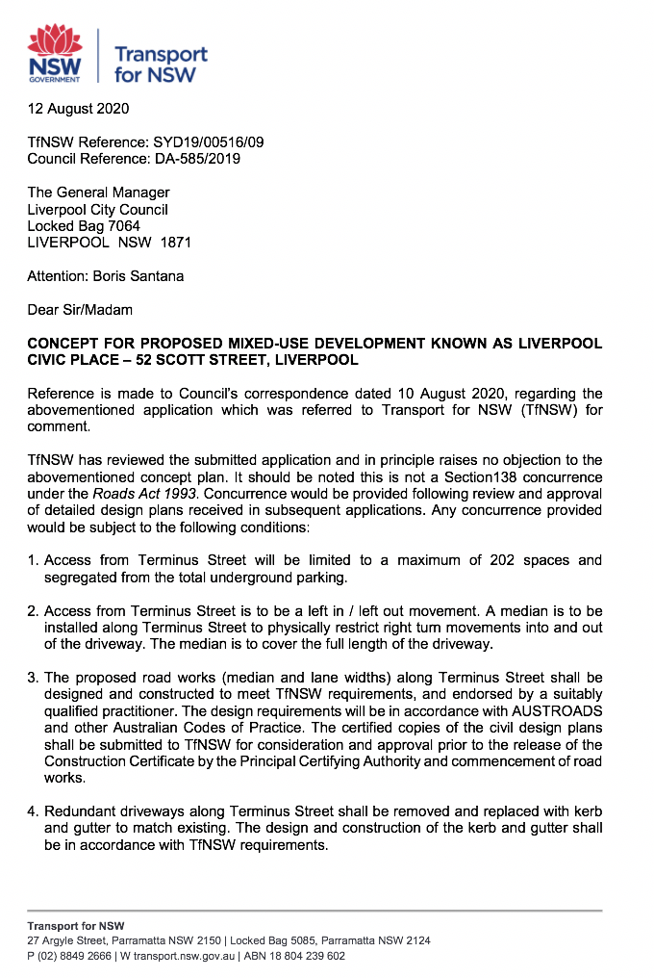
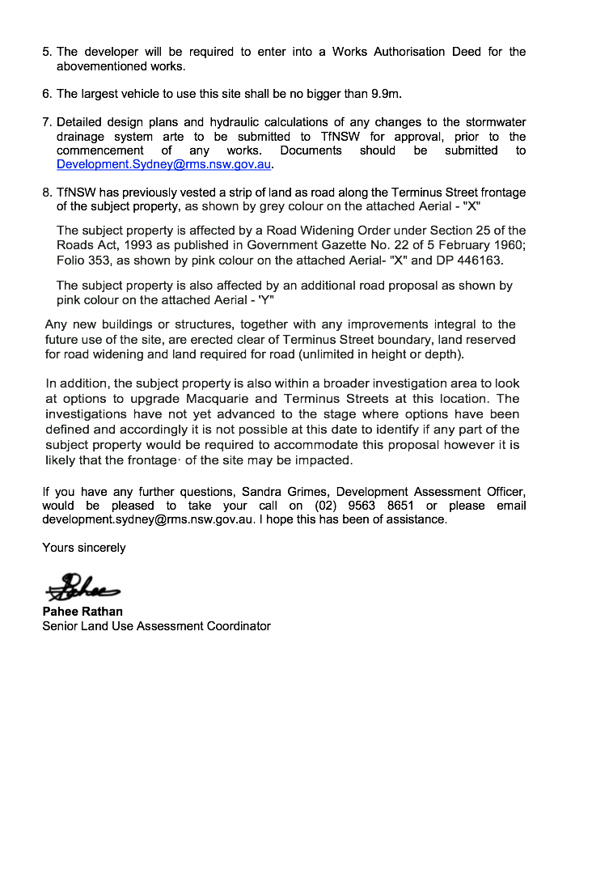
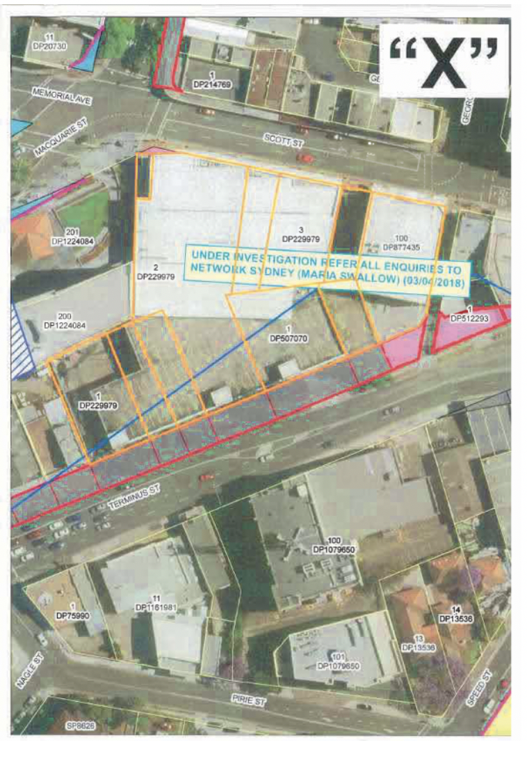
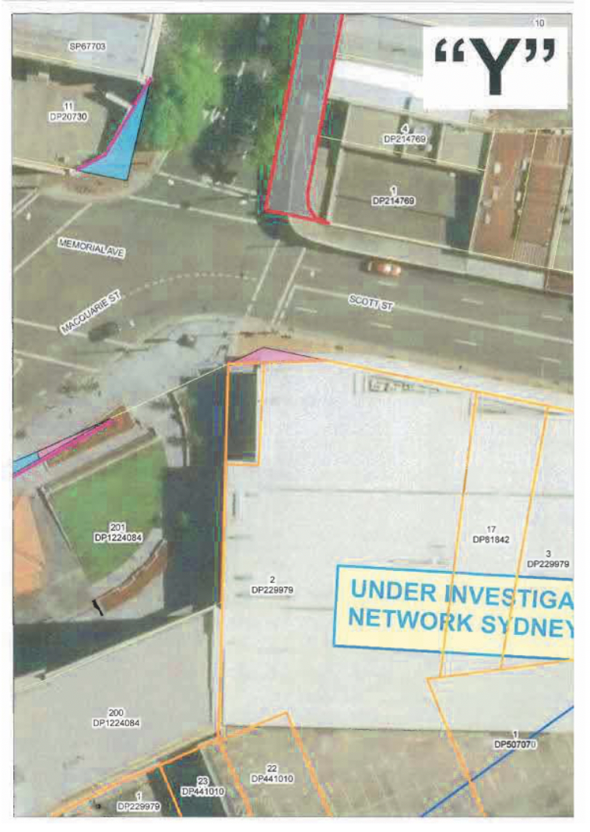

ATTACHMENT 2 – Sydney Water advice

